

PNEUMONIA DETECTION Assignment

Final Report

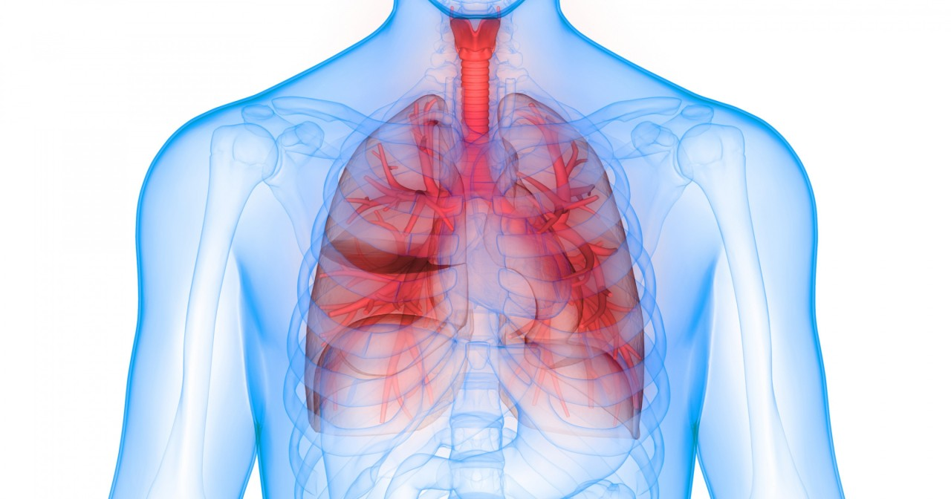

**Team**:

|  |  |
| --- | --- |
| **Name** | **E-mail** |
| Arup Kumar Mohanty | Arup.kumar1988@gmail.com |
| Mohit Gupta | Mohitgupta.mait@gmail.com |
| Ved Verma | Ved.verma.273306@gmail.com |
| Venkatesh Doddihal | Ds.venky1975@gmail.com |

Table of Contents

**1.** **Problem statement, Data and findings** 5

1.1 Understanding the Problem Statement 5

1.1.1 What is Pneumonia? 5

1.1.2 How dangerous is Pneumonia? 5

1.1.3 Is this treatable/preventable? 6

1.1.4 So how to diagnose it? 6

1.1.5 Chest Radiographs basics 7

1.2 Project Objectives: 9

1.3 Data & Findings: 10

**2.** **EDA** 10

2.1 Approach: 10

2.2 Analysis: 11

2.3 Visualization: 14

2.4 Summary: 20

**3.** **Pre-Processing** 21

3.1 Pre-processing Methods 21

3.2 Pre-processing Applied 21

**4.** **Model and Model Building** 23

4.1 Models 23

4.1.1 DenseNet-121 24

4.1.2 CheXNet 26

4.2 Evaluation Metrics 26

4.3 Models Applied 27

4.3.1 DenseNet-121 28

4.3.2 DenseSet-121 with CheXNet weights 30

4.4 Loss/Accuracy Graphs 33

4.5 How to improve performance 34

4.5.1 FCNN Model 34

4.5.3 CNN Model 35

4.5.4 MobileNetV2 Model with Transfer Learning 36

4.5.5 Image Augmentation with Mobile NET: 38

4.6 Results Summary 40

**5.** **Implications** 41

5.1 What causes Pneumonia? 41

5.2 Who is at risk for pneumonia? 41

5.3 How is Pneumonia treated? 41

5.4 Complications of pneumonia? 42

5.5 Key implications about pneumonia 42

**6.** **Limitations** 42

**7.** **Closing Reflections** 43

# **Problem statement, Data and findings**

## 1.1 Understanding the Problem Statement

### 1.1.1 What is Pneumonia?

Pneumonia is an infection that inflames the air sacs in one or both lungs. The air sacs may fill with fluid or pus (purulent material), causing cough with phlegm or pus, fever, chills, and difficulty breathing. A variety of organisms, including bacteria, viruses and fungi, can cause pneumonia.

Pneumonia can range in seriousness from mild to life threatening. It is most serious for infants and young children, people older than age 65, and people with health problems or weakened immune systems.

Most pneumonia occurs when a breakdown in your body's natural defenses allows germs to invade and multiply within your lungs. To destroy the attacking organisms, white blood cells rapidly accumulate. Along with bacteria and fungi, they fill the air sacs within your lungs (alveoli). Breathing may be labored. A classic sign of bacterial pneumonia is a cough that produces thick, blood-tinged or yellowish-greenish sputum with pus.

It requires review of a chest radiograph by highly trained specialists. Pneumonia shows up in a chest radiograph as an area of opacity. However, diagnosis of it can be complicated and specialists in reviewing them spend much time and effort.

### 1.1.2 How dangerous is Pneumonia?

The UNICEF, in its own assessment, has put India in the second rank in terms of the number of deaths caused by pneumonia.

Most deaths occurred among children under the age of two. India accounts for 1.27 lakh deaths owing to pneumonia, ahead of Pakistan and Bangladesh. Only Nigeria is ahead of our country with 1.62 lakh such deaths.

Globally, the disease accounts for 8 lakh deaths, one child every 39 seconds and just five countries are responsible for more than half of child pneumonia deaths — Nigeria (1,62,000), India (1,27,000), Pakistan (58,000), Democratic Republic of Congo (40,000) and Ethiopia (32,000). The UNICEF, in its own assessment, has put India in the second rank in terms of the number of deaths caused by pneumonia.

Most deaths occurred among children under the age of two. India accounts for 1.27 lakh deaths owing to pneumonia, ahead of Pakistan and Bangladesh. Only Nigeria is ahead of our country with 1.62 lakh such deaths.

Globally, the disease accounts for 8 lakh deaths, one child every 39 seconds and just five countries are responsible for more than half of child pneumonia deaths — Nigeria (1,62,000), India (1,27,000), Pakistan (58,000), Democratic Republic of Congo (40,000) and Ethiopia (32,000).

### 1.1.3 Is this treatable/preventable?

The disease can be prevented with vaccines and easily treated with low-cost antibiotics if properly diagnosed. However, tens of millions of children are still going unvaccinated – and one in three with symptoms do not receive essential medical care.

In some severe cases the below image-guided treatments can be used for pneumonia:

1. Thoracentesis: Fluid may be taken from the chest cavity and studied to help the doctor determine which germ is causing your illness. X-ray, CT and/or ultrasound may be used during thoracentesis. The fluid removed during this procedure may also help provide symptom relief.
2. Chest tube placement: During this procedure, also known as thoracostomy, a thin plastic tube is inserted into the pleural space (the area between the chest wall and lungs. The tube can help remove excess fluid or air. The procedure is performed under the guidance of CT or ultrasound.
3. Image-guided abscess drainage: Image-guidance helps direct placement of a needle into the abscess cavity and can aid during insertion of a drainage tube. If an abscess has formed in the lungs, it may be drained by inserting a small drainage tube (catheter). Image guidance, including fluoroscopy, x-ray, ultrasound or CT, is used.

### 1.1.4 So how to diagnose it?

While examination of symptoms is done to understand if the patient does indeed have pneumonia, these steps are usually preliminary steps like:

1. Understanding medical history and symptoms
2. Listening to the lungs - In checking for pneumonia, the doctor will listen for abnormal sounds like crackling, rumbling or wheezing.

But if the doctor thinks that pneumonia is present, an imaging test may be performed to confirm the diagnosis.

One or more of the following tests may be ordered to evaluate for pneumonia:

1. Chest x-ray: An x-ray exam will allow the doctor to see the lungs, heart and blood vessels to help determine if pneumonia is present. When interpreting the x-ray, the radiologist will look for white spots in the lungs (called infiltrates) that identify an infection. This exam will also help determine if there are any complications related to pneumonia such as abscesses or pleural effusions (fluid surrounding the lungs).
2. CT of the lungs: A CT scan of the chest may be done to see finer details within the lungs and detect pneumonia that may be more difficult to see on a plain x-ray. A CT scan also shows the airway (trachea and bronchi) in great detail and can help determine if pneumonia may be related to a problem within the airway. A CT scan can also show complications of pneumonia, abscesses or pleural effusions and enlarged lymph nodes.
3. Ultrasound of the chest: Ultrasound may be used if fluid surrounding the lungs is suspected. An ultrasound exam will help determine how much fluid is present and can aid in determining the cause of the fluid.
4. MRI of the chest: MRI is not generally used to evaluate for pneumonia but may be used to look at the heart, vessels of the chest and chest wall structures. If the lungs are abnormal because of excess fluid, infection or tumor, an MRI may provide additional information about the cause or extent of these abnormalities.
5. Needle biopsy of the lung: The doctor may request a biopsy of your lung(s) to determine the cause of pneumonia. This procedure involves removing several small samples from your lung(s) and examining them. Biopsies of the lung can be done using x-ray, CT, ultrasound and/or MRI.

Chest X-rays are the commonly used method to detect the Pneumonia infection and locate the infected area in the lungs. In addition, the chest X-ray is the widely used radiological examination technique toward diagnosis of several lung diseases. Finding radiological examiners in remote places for analysis for more number of Chest X-rays is an extremely challenging task. In recent times, artificial intelligence approaches are used to solve the challenges in several of medical diagnosis processes.

### 1.1.5 Chest Radiographs basics

In the process of taking an image, an [X-ray](https://en.wikipedia.org/wiki/X-ray) passes through the body and reaches a detector on the other side. Tissues with sparse material, such as lungs, which are full of air, do not absorb X-rays and appear black in the image. Dense tissues such as bones absorb X-rays and appear white in the image. In short –

* Black = Air

* White = Bone

* Grey = Tissue or Fluid

The left side of the subject is on the right side of the screen by convention. You can also see the small L at the top of the right corner. We see the lungs as black in a normal image, but they have different projections on them — mainly the rib cage bones, main airways, blood vessels and the heart.

An example chest radiograph looks like this:

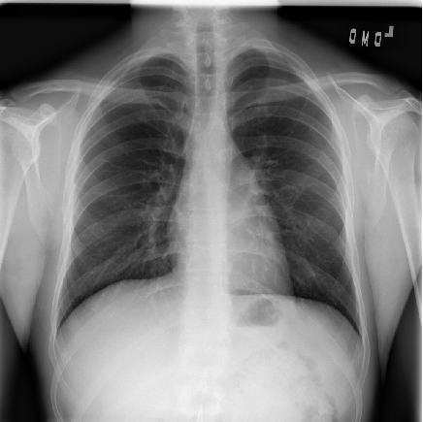

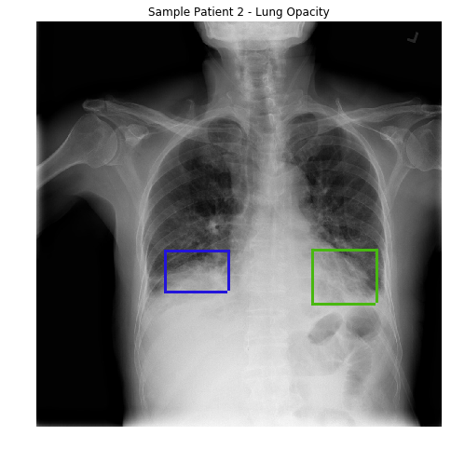

However, the diagnosis of pneumonia on CXR is complicated because of a number of other conditions in the lungs such as fluid overload (pulmonary edema), bleeding, volume loss (atelectasis or collapse), lung cancer, or post-radiation or surgical changes. Outside of the lungs, fluid in the pleural space (pleural effusion) also appears as increased opacity on CXR. When available, comparison of CXRs of the patient taken at different time points and correlation with clinical symptoms and history are helpful in making the diagnosis.

In addition, clinicians are faced with reading high volumes of images every shift. Being tired or distracted clinicians can miss important details in image.

Chest radiograph is the most commonly performed diagnostic imaging study. Due to the high volume of chest radiography, it is very time consuming and intensive for the radiologists to review each image manually.

As such, an automated solution is ideal to locate the position of inflammation in an image. By having such an automated pneumonia screening system, this can assist physicians to make better clinical decisions or even replace human judgement in this area.

Here automated image analysis tools can come to help. For example, **one can use machine learning to automate initial detection (imaging screening) of potential pneumonia cases in order to prioritize and expedite their review**. Hence, we decided to develop a model to detect pneumonia from chest radiographs.

## 1.2 Project Objectives:

The objective is to build an algorithm that can detect visual signals for pneumonia in medical images.

Specifically, the algorithm need to automatically locate lung opacities on chest radiographs, but only the opacities that look like pneumonia, and discard other types of opacities like the ones caused by

* fluid overload (pulmonary edema)
* bleeding, volume loss (atelectasis or collapse)
* lung cancer
* post-radiation
* surgical changes etc.

Outside of the lungs, fluid in the pleural space (pleural effusion) also appears as increased opacity on CXR. A pneumonia opacity is a part of the lungs that looks darker on a radiograph and has a shape that indicates that pneumonia is (or may be) present.

As the objective is to detect and draw a bounding box on each of the pneumonia opacities, where each image can have 0 or many opacities, and the training set is already classified, it can be analysed as a supervised learning statistical multi label classification.

* To build a deep learning a pneumonia detection system, to locate the position of inflammation in an image.
* Use TensorFlow / Keras as the framework for building the model
* Read Medical images are stored in a special format called DICOM files (*.dcm).

## 1.3 Data & Findings:

* Details about the data and dataset files are given in below link,  
  <https://www.kaggle.com/c/rsna-pneumonia-detection-challenge/data>
* The first step would be to examine the data available for this. The data is given in a zip file “rsna-pneumonia-detection-challenge.zip”, which contains the following items:
* A folder “stage_2_train_images”: This folder contains all the training dataset chest radiograph DICOM images.
* A csv file “stage_2_train_labels.csv”: This file contains the corresponding patientID images to the folder “stage_2_train_images” and contains the bounding box of areas of pneumonia detected in each image along with a target label of 0 or 1 for pneumonia detected.
* A csv file “stage_2_detailed_class_info.csv”: This file contains the corresponding patientID images to the folder “stage_2_train_images” and contains the target class labels of the images.
* A folder “stage_2_test_images”: This folder contains all the test dataset chest radiograph DICOM images. We will not be using this set of images, as they do not contain labels.
* A csv file “stage_2_sample_submission.csv”: This file contains the corresponding patientID images to the folder “stage_2_test_images”. We will not be using this set of file.

# **EDA**

## 2.1 Approach:

* To support the building of a neural network, the project will be done on **google Colab**.
* The first step is to unzip the zip file to open the above files to the google drive directory.
* Second step is to verify the format of images as provided, and they are all DICOM images in the “dcm” file format. Read the DICOM images using the **pydicom** library for that purpose. After that, the next step would be to inspect the csv files.

## 2.2 Analysis:

* Loading the “**stage_2_detailed_class_info.csv**” file into pandas dataframe, a quick glance reveals that it has only 2 columns:
* **patientId** – which refers to the patientId’s corresponding image name
* **class** – Target label of the patientId’s image

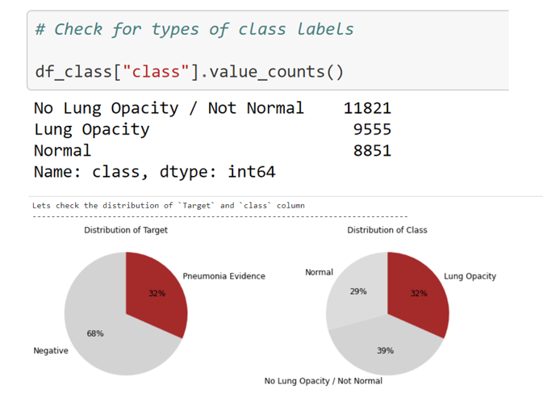

* As illustrate in above figure, there are 3 types of classes: **Normal, Lung Opacity and No Lung Opacity / Not Normal**. 11821(~39%)records belongs to No Lung Opacity / Not Normal, 32% accounts for Lung Opacity and roughly 29% marked as Normal. The primary concern of the project would be to detect images with Lung Opacity, and the others would be in the same group labelling.
* The Target distribution seems to be imbalance as 32% of the patients are having pneumonia evidences where as 68% are normal.
* Loading the “**stage_2_train_labels.csv**” file into pandas dataframe, we can see that it has below fields:

**patientId** – which refers to the patientId’s corresponding image name

**x** - upper-left x coordinate of the bounding box

**y** - upper-left y coordinate of the bounding box

**width** – the width of the bounding box

**height** – the height of the bounding box

**Target** – binary target indicating if this image has evidence of pneumonia

* There is total of 30,227 entries, no missing values with 9,555 images have bounding boxes. This corresponds to the data available “stage_2_detailed_class_info.csv” file.

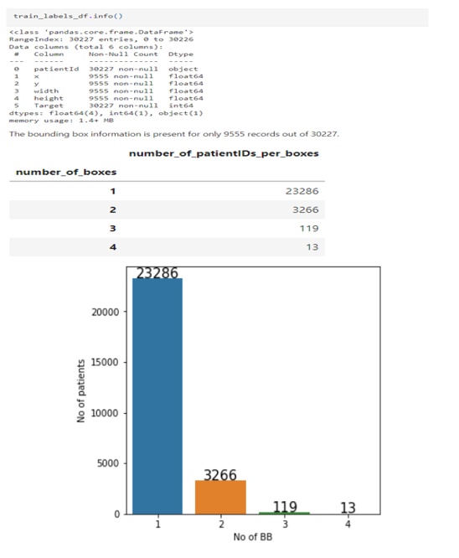

* There are multiple records for patients. Number of duplicates in patientID is 3,543.
* After merging both the csv files below are the observations.
* About 23,286 patients (~87% of them) provided have 1 bounding boxes while 13 patients have 4 bounding boxes. The reason is that each row records a single bounding box area of pneumonia detected. However, in a patient image, it might be the case of several bounding boxes area of pneumonia detected.
* Chest examinations with Target = 1 i.e. ones with evidence of Pneumonia are associated with Lung Opacity class.
* Chest examinations with Target = 0 i.e. those with no definitive evidence of Pneumonia are either of Normal or No Lung Opacity / Not Normal class.
* The next step is to read the images in the file “**stage_2_train_images**”. Images provided are stored in DICOM (.dcm) format, which is an international standard to transmit, store, retrieve, print, process, and display medical imaging information. We will make use of pydicom package here to read the images.

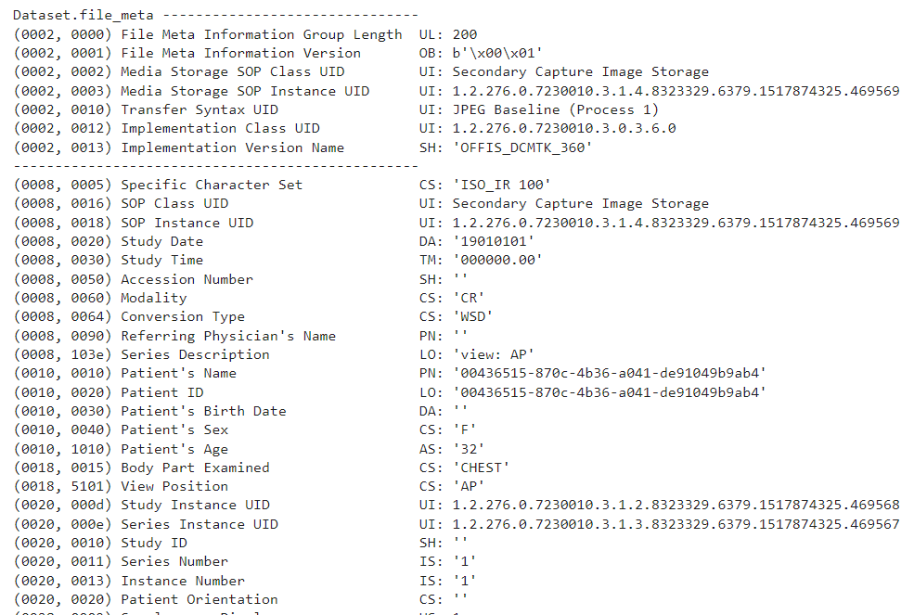

* From the above sample we can see that dicom file contains some of the information that can be used for further analysis such as **sex, age, body part examined , view position and modality**. Size of this image is 1024 x 1024 (rows x columns).
* To examine further we will merge the image features with the existing class data. This will help us understand distribution of age for those with evidence of lung opacity and those with no definite evidence of lung opacity.
* To understand distribution of male and female for those with evidence of lung opacity and those with no definite evidence of lung opacity
* Explore different view positions in the dataset
* Explore modality
* We will pickle the file and do our analysis on the saved file

## 2.3 Visualization:

* As we proceed, further we will use different visualization techniques like univariate, multivariate analysis to discover patterns and anomalies in the data.

**Univariate Analysis:**

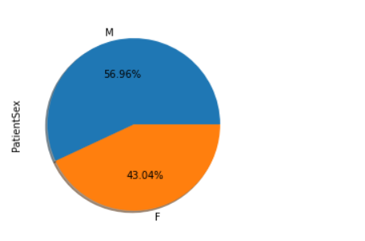

* As shown above, there are 56.96% male patients and roughly 43% female patients. There are also more no of male patients having pneumonia compared to females.

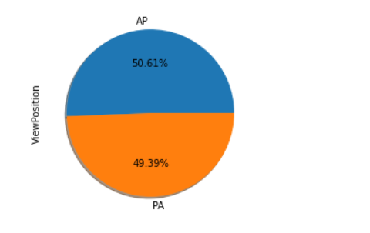

* We have two different view positions AP (Anterior/Posterior) and PA (Posterior/Anterior) in the training dataset.
* **Posterior/Anterior (PA)**: In PA, X-Ray beam hits the posterior (back) part of the chest before the anterior (front) part. While obtaining the image patient is asked to stand with their chest against the film.
* **Anterior/Posterior (AP)**: At times, it is not possible for radiographers to acquire a PA chest X-ray. This is usually because the patient is too unwell to stand. AP projection images are of lower quality than PA images. Heart size is exaggerated (cardiothoracic ratio approximately 50%)
* As can be seen above in the chart, the view position attributes is almost equally distributed.

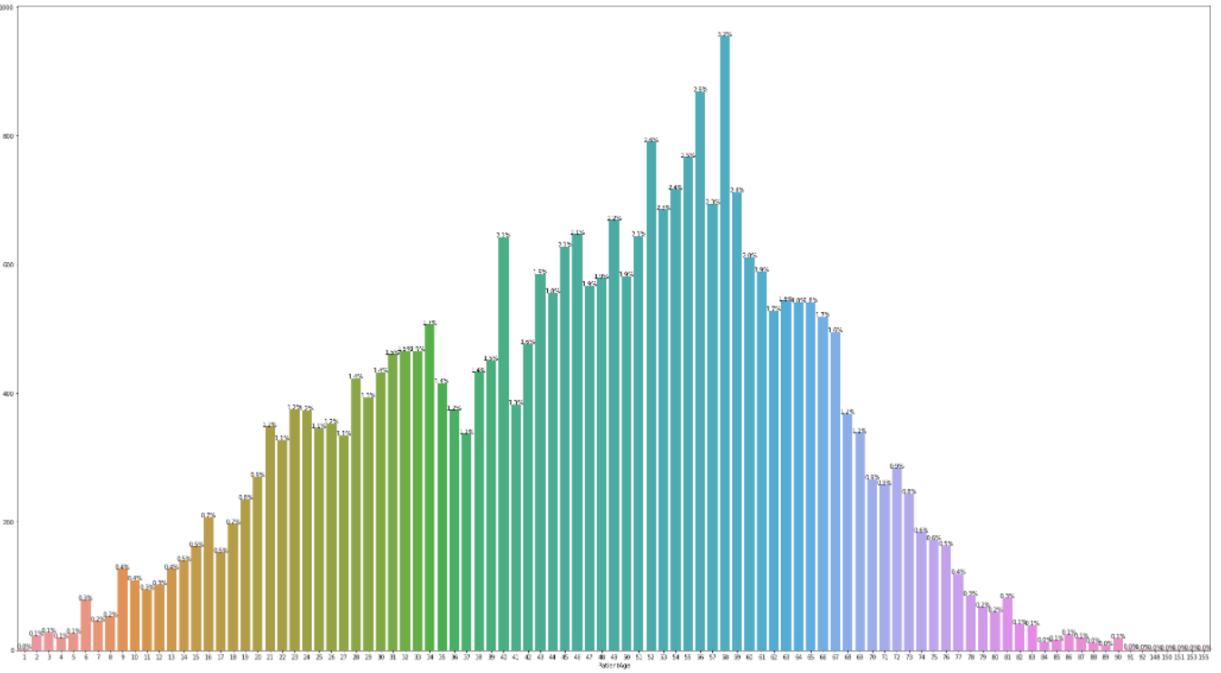

* The above graphs shows the distribution of age across all the patients. As per the data the maximum no of patients are falling within age group 40-60.
* There are also few patients where age > 100. These records seems to be erronous and we can safely remove them from our dataset and will keep the age

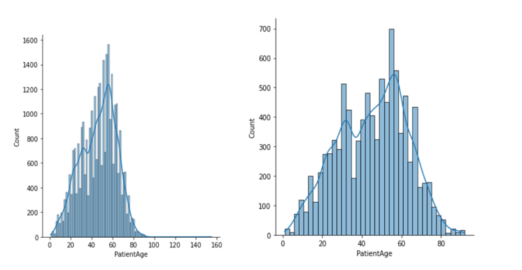

* As per the above histogram, the patient age is normally distributed with more volume of data lying between age group 40-60.
* The Age distribution for pnenumonia patient is slightly left skewed with more no of patient between age group 40-60 are having pneumonia.

**Bivariate Analysis:**

* To have a better interpretation we will make use of binning concept as shown below to group the patient age and will further visualize on the transformed data.

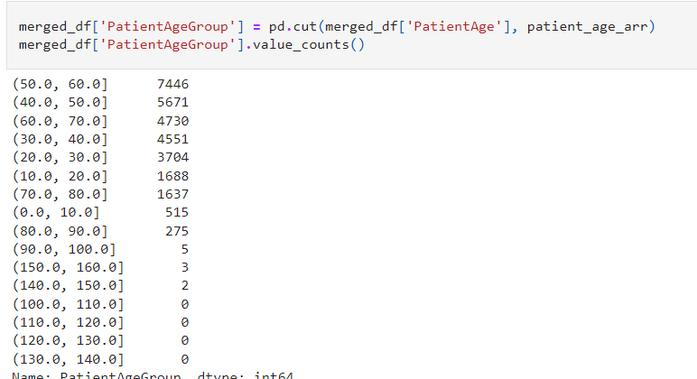

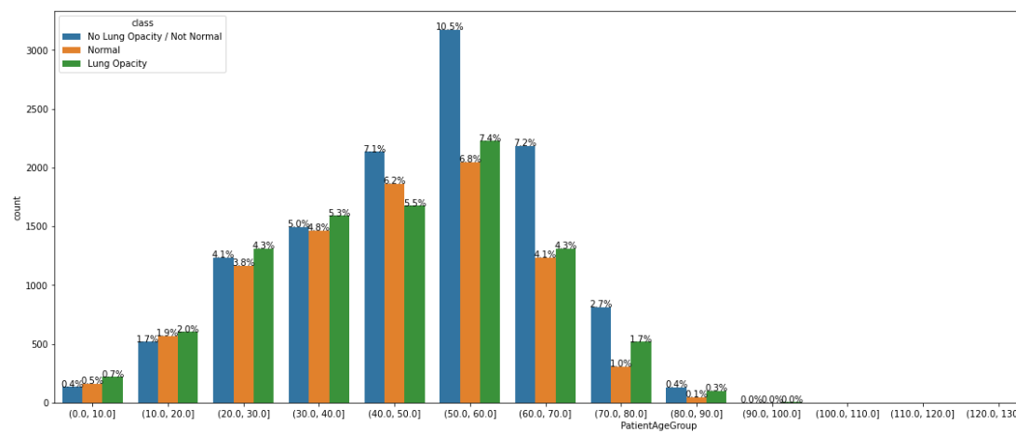

* The above picture depicts a distribution of different classes across the ‘PatientAgeGroup’.
* As can be seen patients with age group between 50-60 are having the highest probability of getting pnenumonia compared to other age groups.
* There are very less no of data points for age group>70.

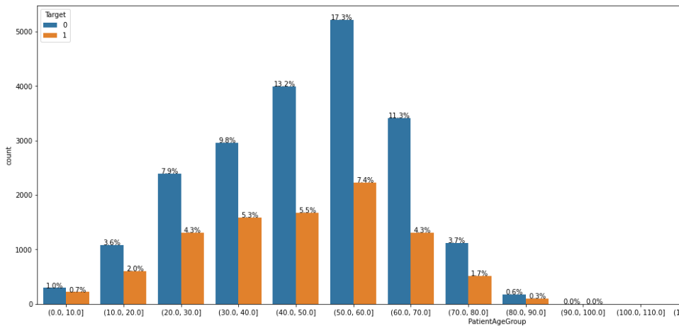

* The distribution of Age group with Target variable also reflects maximum no of postive cases between 40-60. For age group 50-60 there are 17.3% of patients who doesn’t have pneumonia compared to 7.4% who have.

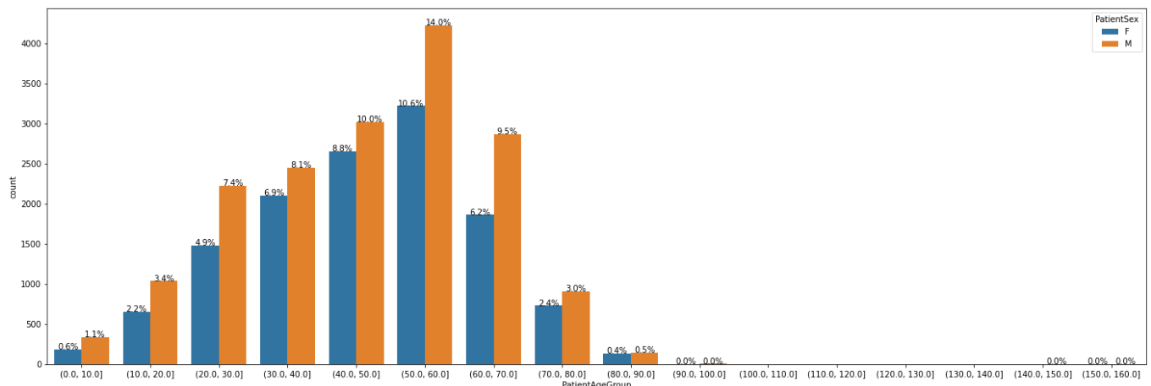

* The distribution of patient sex vs Age group shows there are maximum no of male and female present in age group 50-60 which is 14% and 10.6% respectively.
* Next majority falls between age group 40-50.
* There are very less no of records exists for age group 0-10 and 80-100.

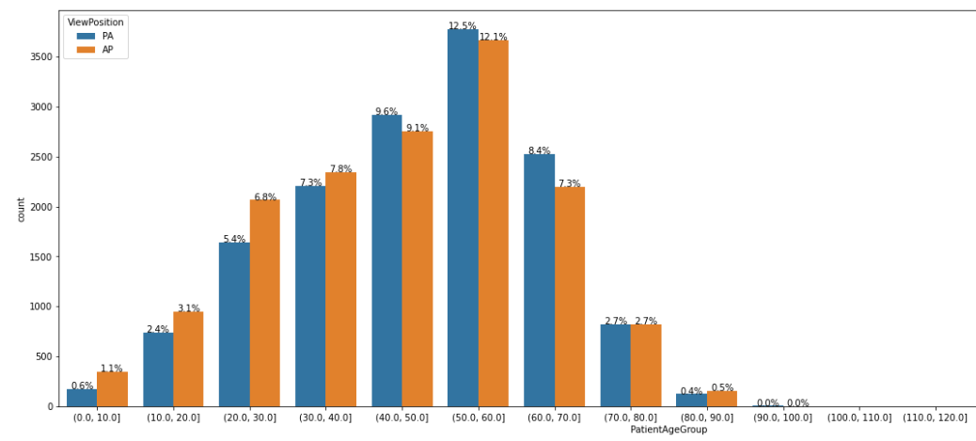

* Above picture illustrate the PA and AP view position for different Age group.
* Data shows for age group 50-60 there are 12.5% patients with AP and 12.1 % with PA position.
* Amongs all the patients between age group 30-40, 9.6% are having AP and 9.1% are having PA view positions.
* For agegroup 0-10 and 80-100 we have very less data available.
* Before proceeding, it would be good to view how the images are displayed. So loading a few DICOM images in google Colab. We will read images from training samples for both normal as well as for pneumonia patients as shown below.

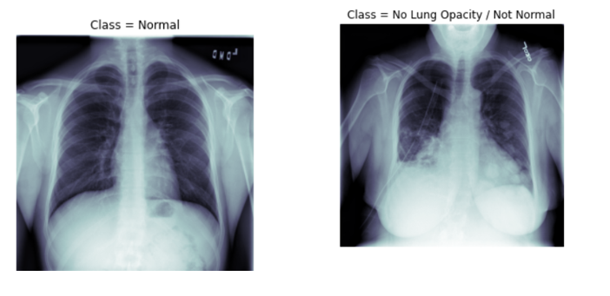

* The above two images represents classes **‘Normal’** and ‘**No Lung Opacity / Not Normal’.** In the normal class, the image is quite prominent with no sign of any lungs opacity.
* The second image signifies a patient with **No Lung Opacity / Not Normal’.** Even though it does not have any Lung Opacity, still some portion of the image is blurred giving a notion of Not normal lungs. Medical practitioners will further validate these sort of cases.

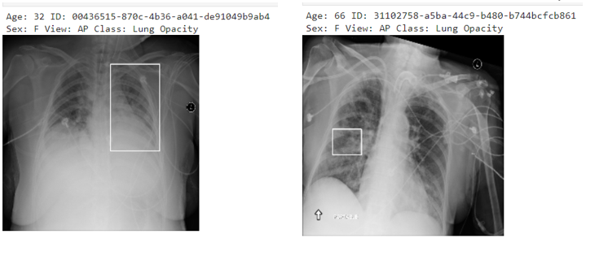

* Above two screenshot shows patients having lungs opacity. As can be seen there are bounding box on each of the images pointing the infections. There will be region of infection based on which the bounding box coordinates have been defined.

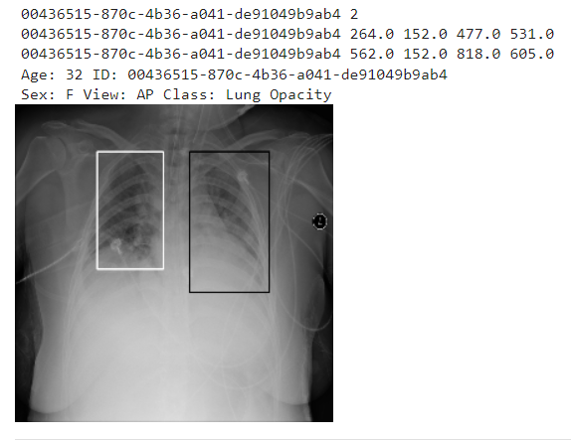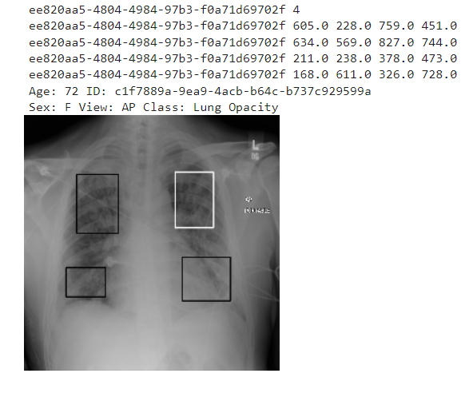

* In addition, there are patient id’s which are duplicate or have multiple bounding boxes. This is valid as the patients might have multiple area with infections.
* As shown above the first image shows two bounding boxes/lungs opacity for the same patient id.
* Similarly, for the second image there are 4 regions of infection for the same patient.

## 2.4 Summary:

* The training dataset (both of the csv files and the training image folder) contains information of 26684 patients (unique)
* Out of these 26684 unique patients some of these have multiple entries in the both of the csv files
* Most of the recorded patient belong to Target = 0 (i.e., they don't have Pneumonia)
* Some of the patients have more than one bounding box. The maximum being 4
* The classes "No Lung Opacity / Not Normal" and "Normal" is associated with Target = 0 whereas "Lung Opacity" belong to Target = 1
* The images are present in dicom format, from which information like PatientAge, PatientSex, ViewPosition etc are obtained
* There are two ways from which images were obtained: AP and PA. The age ranges from 1-155 (which were further clipped to 100)
* The centers of the bounding box are spread out over the entire region of the lungs. However, there are some centres, which are outliers.

# **Pre-Processing**

This section describes the pre-processing steps applied to data before modelling. The images are in dicom format, which contains lot of metadata along with pixel data. The pixel data needs to be extracted and converted to either jpg or png format.

## 3.1 Pre-processing Methods

The following pre-processing methods can be applied to images.

* Conversion of image to jpg or png format.
* Find the number of channels in images and align to 1 or 3 channels.
  + Convert images to grey scale.
* Image resizing required as per base model requirements like 224*224 for VGG16.
* Drop duplicate data.
* Set null values to 0 or drop the rows.
* Pixel normalization. The pixel intensity values are modified to a range of values This is also known as contrast stretching.
* Image augmentation is technique used to artificially generate more variations in existing data and create additional variety in training images. This technique helps in generalizing the model better and avoids overfitting. Some of the transformations that can be applied are,
  + Rotate the images by specified angle.
  + Flip vertically or horizontally.
  + Shearing - shift one part of the image like parallelogram.
  + Generate masks for the image.
  + Thresholding – used to binarize grey scale images.
  + Erosion, Dilation – Used to either erode certain features or make them prominent.
  + Crop the images and generate many sub-sets from original images.

## 3.2 Pre-processing Applied

* The data generators are used to pre-process the image.
* The images are resized to 224*224 and processed in batches of 32.
* Duplicate rows were dropped from merged data frame “train_feature_engineered”.
* The total number records after dropping duplicates are 26684.
* The distribution of target variable and classes are given below.

Distribution of target and classes

0 20672

1 6012

Name: Target, dtype: int64

No Lung Opacity / Not Normal 11821

Normal 8851

Lung Opacity 6012

Name: class, dtype: int64

* The shape of data after split into train, test and validation are as below.

Shape of the dataframes:

TRAIN:(21348, 3)

VALID:(2668, 3)

TEST:(2668, 3)

* The data distribution is proper across train, test and validation data set.

Distribution of target in the training set:

0 0.78

1 0.22

Name: Target, dtype: float64

Distribution of target in the validation set:

0 0.78

1 0.22

Name: Target, dtype: float64

Distribution of target in the test set:

0 0.77

1 0.23

Name: Target, dtype: float64

# **Model and Model Building**

This section describes the approach used in modelling and the different techniques applied along with their evaluation.



## Models

The problem of lung opacity detection involves both classification and regressions. It is a classification problem, as the model needs to identify if lung opacity is present or absent to aid in the detection of pneumonia. It is a regression problem, as the model needs to identify the pixel areas containing the lung opacity. Some of the techniques, which can be used, are,

* Fast R-CNN
* Faster R-CNN
* Single Shot Detector (SSD)
* YOLO (You Look Only Once)
* SPP-net

Techniques based on R-CNN require lot of images for training and requires lot of training time with high resource consumption. SSD and YOLO perform better on time and resources comprising on accuracy. In order to overcome the above limitations, techniques of transfer learning based on existing models and their weights can be used to get better accuracy with reduced training data set in relatively less time.

Some of the pre-trained models suitable for opacity detection are,

* Densenet-121
* VGG 16
* ResNet-50
* CheXNet

### DenseNet-121

DenseNet-121 has been designed to address the “vanishing gradient” problem with traditional CNN’s as number of layers become more. In this architecture each layer is connected directly to every layer. In case of N Layers, there are N(N+1)/2 connections.

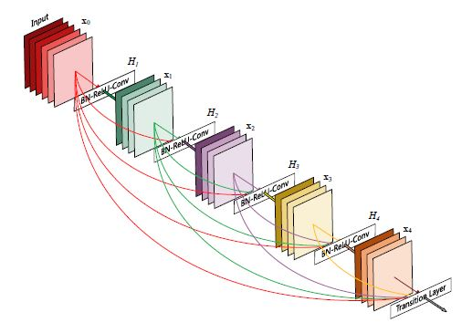

Figure 1: DenseNet-121 Architecture

The following layers are present in DenseNet-121,

* 1 7x7 Convolution
* 58 3x3 Convolution
* 61 1x1 Convolution
* 4 AvgPool
* 1 Fully Connected Layer

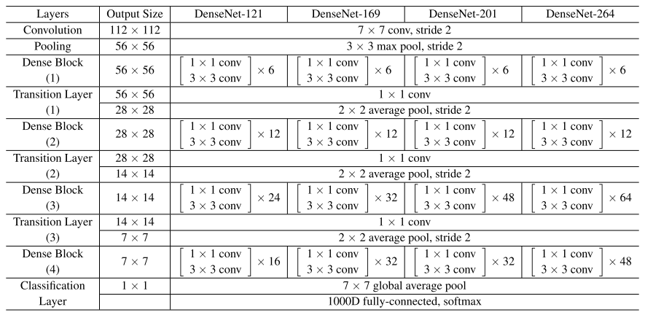

Figure 2: DenseNet-121 Details

The Dense blocks has varying number of layers with two convolutions. 1*1 sized bottleneck layer and 3*3 sized kernel for convolution. It has 120 convolutions and 4 average pools.

The key advantage is it requires fewer parameters and allows reuse of features resulting in compact models providing better performance compared to Resnet or other models.

### CheXNet

CheXNet is model relies on pre-trained weights of ImageNet and trained on NIH chest X-ray images. This model is specifically trained to detect Pneumonia and is based on DenseNet-121

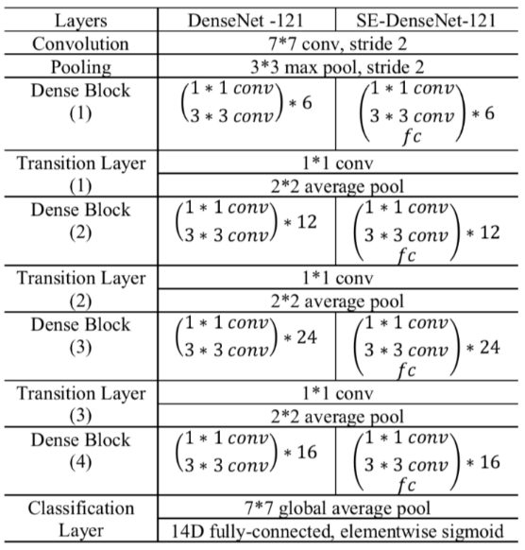

Figure 3: CheXNet Details

## Evaluation Metrics

Following metrics will be used for classification,

* **Precision**

Precision is one indicator of a machine-learning model's performance – the quality of a positive prediction made by the model. Precision refers to the number of true positives divided by the total number of positive predictions (i.e., the number of true positives plus the number of false positives)

* **Recall**

The recall is calculated as the ratio between the numbers of Positive samples correctly classified as Positive to the total number of Positive samples. The recall measures the model's ability to detect positive samples. The higher the recall, the more positive samples detected. Recall can be thought of as a measure of a classifiers completeness. A low recall indicates many False Negatives.

* **F1-Score**

The [F1 Score](https://en.wikipedia.org/wiki/F1_score) is the 2*((precision*recall)/(precision+recall)). It is also called the F Score or the F Measure. Put another way, the F1 score conveys the balance between the precision and the recall.

* **Accuracy**

Accuracy is a metric for classification models that measures the number of predictions that are correct as a percentage of the total number of predictions that are made. As an example, if 90% of your predictions are correct, your accuracy is simply 90%.

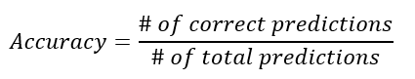

Accuracy is a useful metric only when you have an equal distribution of classes on your classification. This means that if you have a use case in which you observe more data points of one class than of another, the accuracy is not a useful metric anymore.

* **ROC Curve**

ROC curve, also known as Receiver Operating Characteristics Curve, is a metric used to measure the performance of a classifier model. The ROC curve depicts the rate of true positives with respect to the rate of false positives, therefore highlighting the sensitivity of the classifier model.

IOU and mAP (mean Average Precision) will be used for evaluating regression part of the model.

## Models Applied

Data generators are used to load the data and pre-process them.

The Models applied:

* DenseNet-121
* DenseNet-121 with CheXNet weights.

### DenseNet-121

Summary of model trainable parameters.

Create a `DenseNet121` model

----------------------------------------------------------------------

Model: "DenseNet121"

_________________________________________________________________

Layer (type) Output Shape Param #

=================================================================

DenseNet121 (Functional) (None, 7, 7, 1024) 7037504

global_average_pooling2d (G (None, 1024) 0

lobalAveragePooling2D)

dropout (Dropout) (None, 1024) 0

dense (Dense) (None, 1) 1025

=================================================================

Total params: 7,038,529

Trainable params: 6,954,881

Non-trainable params: 83,648

_________________________________________________________________

There are total of 6,954,881 trainable parameters.

The model was executed for 10 epochs with batch size of 32. The binary cross entropy loss is around 0.3 and validation accuracy of 85%.

The results for model run on evaluation data are,

Evaluate the model on validation data

-----------------------------------------------------------------------

Loss: 0.338, Accuracy: 0.843, Average Precision: 0.665, F1 Score: 0.612

AUC: 0.890

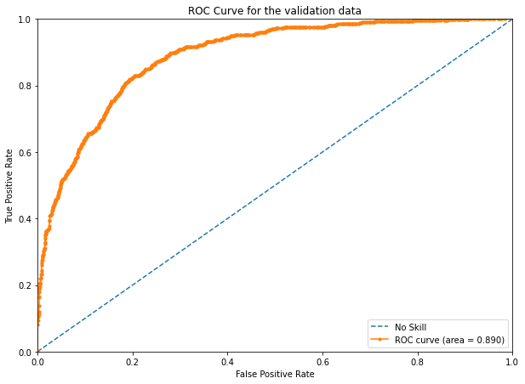

Figure 4: ROC for Validation data

ROC Curve for the test data

---------------------------------------------------------------------------

AUC: 0.894

Figure 5:ROC for test data

The AUC is similar for validation and test data.

The confusion matrix for test data indicating the predictions is shown below.

Figure 6: CM for test data

The classification report for test data :

Classification Report on the test data

------------------------------------------------------------------------------------------------------------------------

precision recall f1-score support

Normal 0.87 0.93 0.90 2042

Pneumonia 0.72 0.55 0.62 626

accuracy 0.84 2668

macro avg 0.79 0.74 0.76 2668

weighted avg 0.84 0.84 0.84 2668

The F1-score for Normal class is 0.9 indicating a high accuracy. The F1-score of 0.62 is low for Pneumonia class which is the main objective of the model.

### DenseSet-121 with CheXNet weights

The summary of model:

Create a `CheXNet-like` model using pre-trained weights

--------------------------------------------------------------------------------

Model: "CheXNet-like"

_________________________________________________________________

Layer (type) Output Shape Param #

=================================================================

CheXNet-like (Model) (None, 1024) 7037504

_________________________________________________________________

dropout (Dropout) (None, 1024) 0

_________________________________________________________________

dense (Dense) (None, 1) 1025

=================================================================

Total params: 7,038,529

Trainable params: 6,954,881

Non-trainable params: 83,648

_________________________________________________________________

The loss is around ~0.32 and accuracy is 85% after model execution on training samples for 10 epochs with batch size of 32.

Summary for evaluation on validation data:

Evaluate the model on validation data

-----------------------------------------------------------------------Loss: 0.325, Accuracy: 0.848, Average Precision: 0.692, F1 Score: 0.61

ROC Curve for validation data.

AUC: 0.898

Figure 7:ROC for validation data

ROC curve for test data:

AUC:0.895

Figure 8: ROC for test data

The confusion matrix for predicted labels:

Figure 9: CM for predicted class

The classification report on test data:

Classification Report on the test data

-----------------------------------------------------------------------

precision recall f1-score support

Normal 0.87 0.93 0.90 2042

Pneumonia 0.72 0.55 0.63 626

accuracy 0.85 2668

macro avg 0.80 0.74 0.76 2668

weighted avg 0.84 0.85 0.84 2668

The classification report shows that F1-score for Pneumonia class is still low showing a very marginal improvement.

## Loss/Accuracy Graphs

The graphs show the variation in loss and accuracy during training and validation for denseNet-121 and densenet-121 with Chexnet weights.

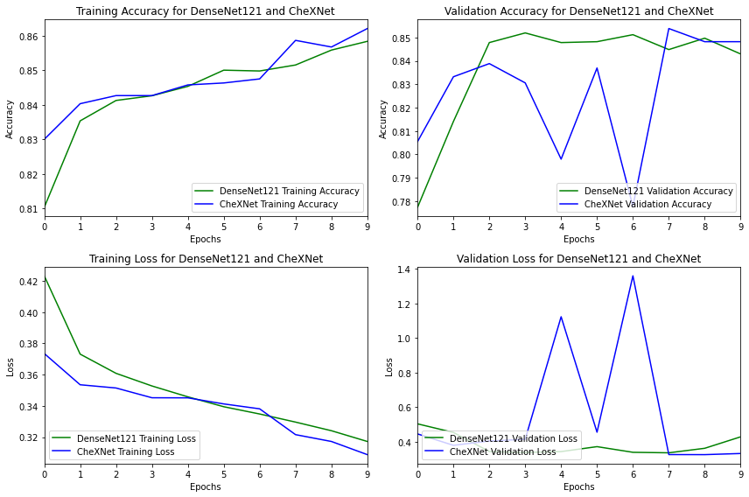

Figure 10:DenseNet vs Chexnet loss & accuracy

Observations:

* It is observed that training accuracy for DenseNet-121 is starting a lower value than the model with CheXnet weights. At the end of 10 epochs, both models reach similar accuracy.
* The validation accuracy swings low and high during epochs where as DenseNet-121 accuracy goes high and then stays around a median.
* Training loss for DenseNet121 is high initially but in the end goes down to 0.33.Loss is slightly better when CheXNet weights are used.
* Swings are observed when ChexNet weights are used in validation loss. In the end, validation loss is better when Chexnet weights are used.

## How to improve performance

Since the F1-score for Pneumonia class is around 0.63 and accuracy around 85% is not optimal for the given problem, following methods can be applied to improve performance,

* Data augmentation.
  + Rotate.
  + Flip.
  + Masking.
* FCNN model.
* CNN model.
* Apply transfer-learning methods, using MobileNetV2 model

### FCNN Model

Summary of model trainable parameters:

Model: "sequential"

_________________________________________________________________

Layer (type) Output Shape Param #

=================================================================

flatten (Flatten) (None, 49152) 0

dense (Dense) (None, 128) 6291584

dense_1 (Dense) (None, 1) 129

=================================================================

Total params: 6,291,713

Trainable params: 6,291,713

Non-trainable params: 0

_________________________________________________________________

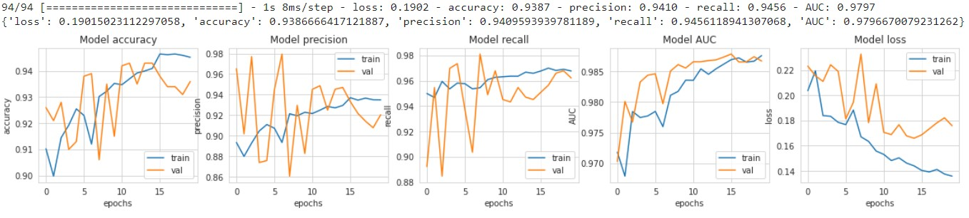

### CNN Model

In Convolutional Neural Network, the model first learns the features from the images and based on that it helps in classification.

The reason for popularity of CNN is its very good execution while classifying. CNN was founded on the idea of recognizing handwritten zip codes. It is a feed-forward kind of NN. Composition of multiple layers of artificial neurons forms Convolutional neural networks.

There is first the Convolutional Layer: which is responsible for learning the characteristics of the images input,

Then there is Max-Pooling Layer: it performs max-pooling operation by selecting max value from kernel matrix,

Then comes Fully Connected Layer: all the neurons of a particular layer are connected to the neurons of the next layer to prepare the network for classification capabilities.

Summary of model trainable parameters:

Model: "sequential_1"

_________________________________________________________________

Layer (type) Output Shape Param #

=================================================================

conv2d (Conv2D) (None, 126, 126, 32) 896

max_pooling2d (MaxPooling2D (None, 63, 63, 32) 0

)

conv2d_1 (Conv2D) (None, 61, 61, 32) 9248

max_pooling2d_1 (MaxPooling (None, 30, 30, 32) 0

2D)

dropout (Dropout) (None, 30, 30, 32) 0

conv2d_2 (Conv2D) (None, 28, 28, 64) 18496

conv2d_3 (Conv2D) (None, 26, 26, 128) 73856

batch_normalization (BatchN (None, 26, 26, 128) 512

ormalization)

max_pooling2d_2 (MaxPooling (None, 13, 13, 128) 0

2D)

dropout_1 (Dropout) (None, 13, 13, 128) 0

flatten_1 (Flatten) (None, 21632) 0

dense_2 (Dense) (None, 512) 11076096

batch_normalization_1 (Batc (None, 512) 2048

hNormalization)

dropout_2 (Dropout) (None, 512) 0

dense_3 (Dense) (None, 128) 65664

batch_normalization_2 (Batc (None, 128) 512

hNormalization)

dropout_3 (Dropout) (None, 128) 0

dense_4 (Dense) (None, 1) 129

=================================================================

Total params: 11,247,457

Trainable params: 11,245,921

Non-trainable params: 1,536

_________________________________________________________________

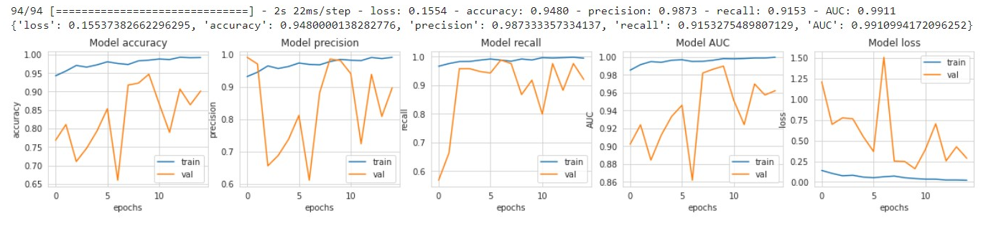

### MobileNetV2 Model with Transfer Learning

Transfer learning is the use of a model trained already on a huge dataset in subsequent training procedures with a small available dataset while preserving the weights obtained in the original training is known as transfer learning.

Using a pre-trained model as the starting point for some particular and related tasks , in another expression, helps to save time and computing resources. Since the CNN learned to extract features from images in the initial training process and depending on the capability to extract the most significant and important ones. In the next phase and during the new training the CNN and according to its past knowledge in features extraction which was obtained during the original training, there are two ways to utilize the capabilities of the pre-trained CNN.

* First way is to use the pre-trained convolutional neural network as a feature extractor, this technique is called feature extraction via transfer learning , what differentiates it is that the classification operation uses weighs and features from the precedent extraction and feed it into a new network that performs the classification task.
* Second way (used in this paper) and a more sophisticated procedure is to retain specific knowledge mined from the previous task and to feed it into a modified CNN architecture with the tuning of the trainable parameters.

Summary of model trainable parameters:

Downloading data from https://storage.googleapis.com/tensorflow/keras-applications/mobilenet_v2/mobilenet_v2_weights_tf_dim_ordering_tf_kernels_1.0_128_no_top.h5

9412608/9406464 [==============================] - 0s 0us/step

9420800/9406464 [==============================] - 0s 0us/step

Model: "sequential_2"

_________________________________________________________________

Layer (type) Output Shape Param #

=================================================================

mobilenetv2_1.00_128 (Funct (None, 4, 4, 1280) 2257984

ional)

global_average_pooling2d (G (None, 1280) 0

lobalAveragePooling2D)

dense_5 (Dense) (None, 1) 1281

=================================================================

Total params: 2,259,265

Trainable params: 1,281

Non-trainable params: 2,257,984

_________________________________________________________________

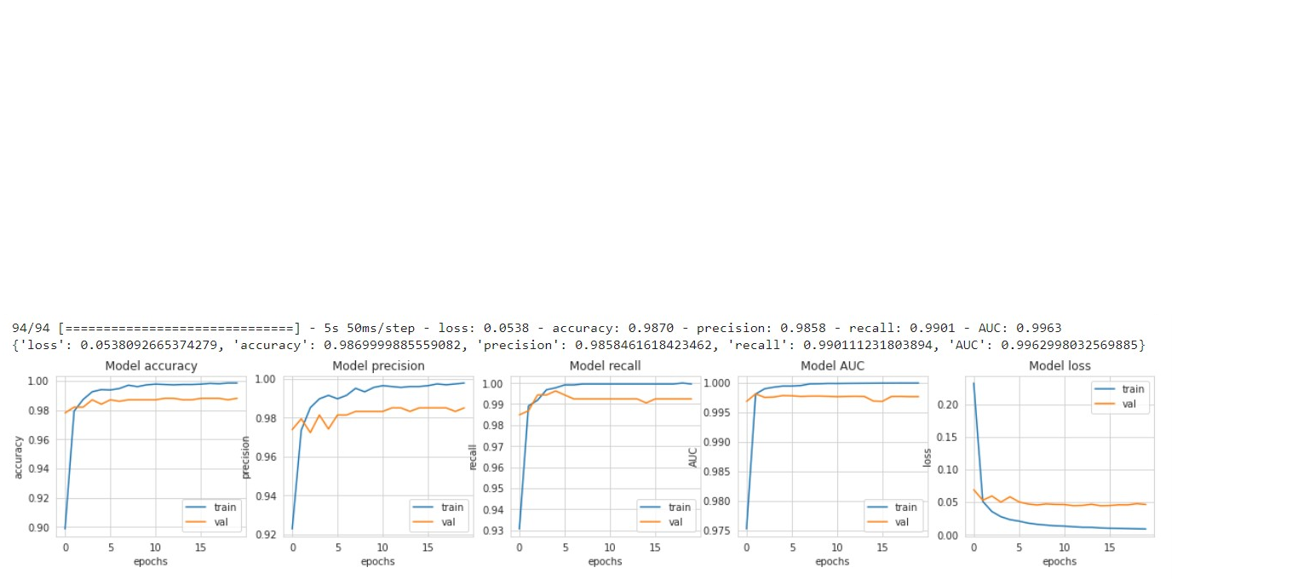

### Image Augmentation with Mobile NET:

* Image augmentation is a technique of altering the existing data to create some more data for the model training process. In other words, it is the process of artificially expanding the available dataset for training a deep learning model
* We performed data augmentation by transforming the pictures (random rotation, flipping, random grayscale, and horizontal and vertical shifting) to produce more diversity in the dataset.
* Similar as above, we tried training the dataset through Mobile Net transfer learning technique. The dataset was split into train, validation and test.
* Few sample image after augmentation as shown below.

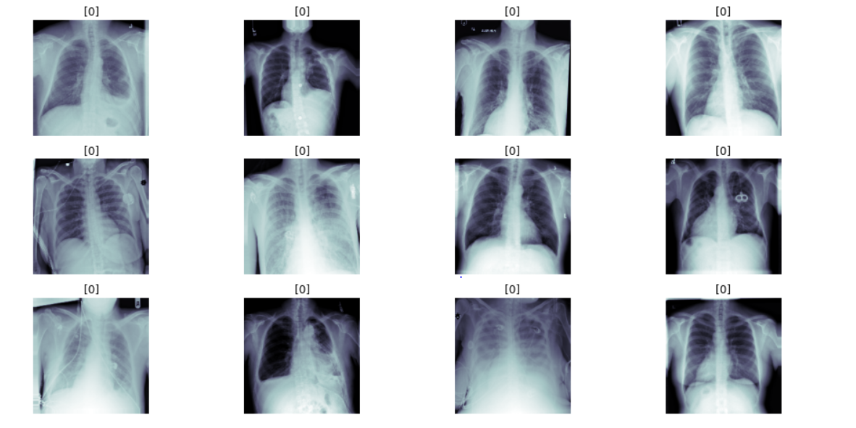

* The model was trained with the base imagenet dataset followed by a dense layer of MobileNet.
* Callbacks used for this case was CSVlogger, ReduceLROnPlateau.
* Below screenshots talks about the model overview, AUC curve and confusion matrix readings.
* The results were not satisfactory with image augmentation as the model was highly overfitting.

Summary of model trainable parameters:

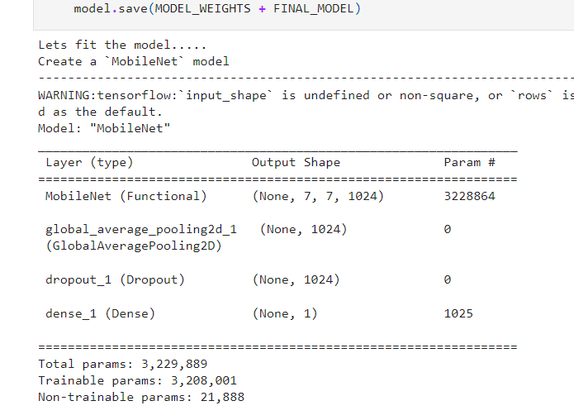

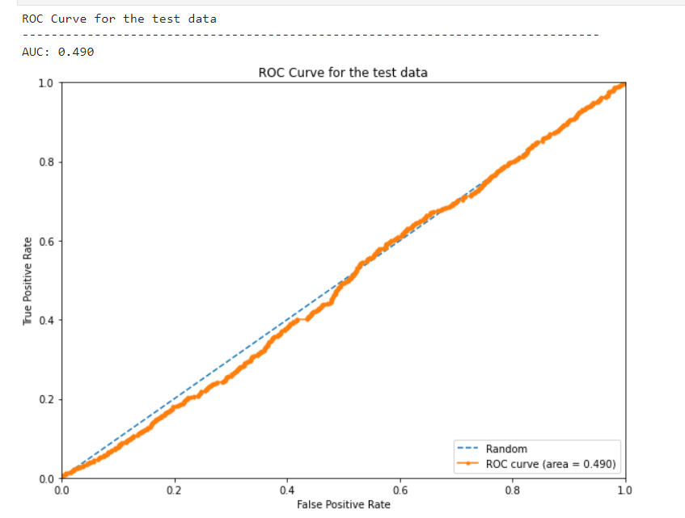

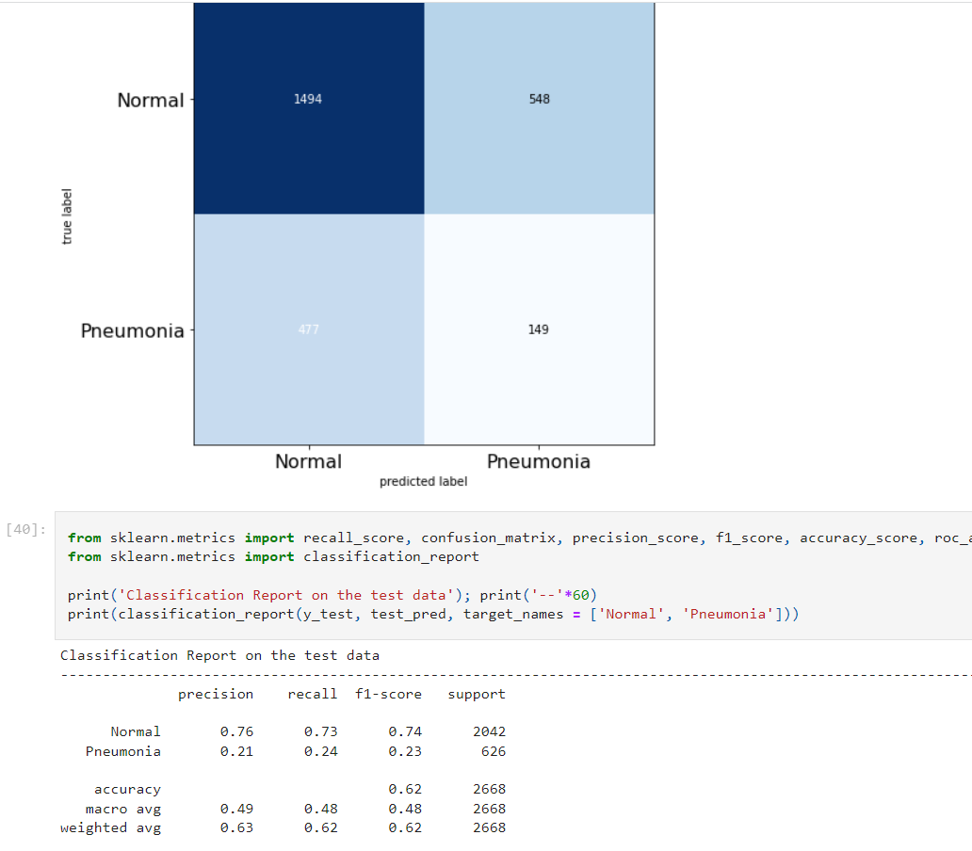

## Results Summary

|  |  |  |  |  |  |  |
| --- | --- | --- | --- | --- | --- | --- |
| **S. No.** | **Model** | **Class** | **Accuracy** | **Recall** | **Precision** | **F1-Score** |
| 1 | DenseNet 121 | Normal | 84% | 0.93 | 0.87 | 0.9 |
| 2 | DenseNet 121 | Pneumonia | 84% | 0.55 | 0.72 | 0.62 |
| 3 | DenseNet121+CheXnet weights | Normal | 85% | 0.93 | 0.87 | 0.9 |
| 4 | DensetNet121+CheXnet weights | Pneumonia | 85% | 0.55 | 0.72 | 0.63 |  |  |  | 84% | 0.93 | 0.87 | 0.9 |
| 5 | FCNN | Pneumonia | 93.9% | 0.95 | 0.94 | 0.95 |  |  |  | 84% | 0.55 | 0.72 | 0.62 |
| 6 | CNN | Pneumonia | 94.8% | 0.91 | 0.98 | 0.94 |  |  |  | 85% | 0.93 | 0.87 | 0.9 |
| 7 | MobileNetV2 with Transfer learning | Pneumonia | 98.7% | 0.98 | 0.99 | 0.98 |  |  |  |  |  |  |  |
| 8 | MobileNet with image augmentation | Pneumonia | 62% | 0.24 | 0.21 | 0.23 |  |  |  | 85% | 0.55 | 0.72 | 0.63 |

# **Implications**

## What causes Pneumonia?

There are more than 30 different causes of pneumonia, and they are grouped by the cause. The main types of pneumonia are:

* **Bacterial pneumonia.** This type is caused by various bacteria. The most common is *Streptococcus pneumoniae*. It usually occurs when the body is weakened in some way, such as by illness, poor nutrition, old age, or impaired immunity, and the bacteria are able to work their way into the lungs. Bacterial pneumonia can affect all ages, but you are at greater risk if you abuse alcohol, smoke cigarettes, are debilitated, have recently had surgery, have a respiratory disease or viral infection, or have a weakened immune system.
* **Viral pneumonia.** This type is caused by various viruses, including the flu (influenza), and is responsible for about one-third of all pneumonia cases. You may be more likely to get bacterial pneumonia if you have viral pneumonia.
* **Mycoplasma pneumonia.** This type has somewhat different symptoms and physical signs and is referred to as atypical pneumonia. It is caused by the bacterium *Mycoplasma pneumoniae*. It generally causes a mild, widespread pneumonia that affects all age groups.
* **Other pneumonias.** There are other less common pneumonias that may be caused by other infections including fungi.

## Who is at risk for pneumonia?

Anyone can get pneumonia. However, the following groups are at the highest risk:

* Adults ages 65 and older
* Children younger than age 2
* People with certain medical conditions
* People that smoke

## How is Pneumonia treated?

Treatment depends on the type of pneumonia you have. Most of the time, pneumonia is treated at home, but severe cases may be treated in the hospital. Antibiotics are used for bacterial pneumonia. Antibiotics may also speed recovery from mycoplasma pneumonia and some special cases. Most viral pneumonias don’t have specific treatment. They usually get better on their own.

Other treatment may include eating well, increasing fluid intake, getting rest, oxygen therapy, pain medicine, fever control, and maybe cough-relief medicine if cough is severe.

## Complications of pneumonia?

Most people with pneumonia respond well to treatment, but pneumonia can be very serious and even deadly.

You are more likely to have complications if you are an older adult, a very young child, have a weakened immune system, or have a serious medical problem like diabetes or cirrhosis. Complications may include:

* **Acute respiratory distress syndrome (ARDS).** This is a severe form of respiratory failure.
* **Lung abscesses.** These are pockets of pus that form inside or around the lung. They may need to be drained with surgery
* **Respiratory failure.** This requires the use of a breathing machine or ventilator.
* **Sepsis.** This is when the infection gets into the blood. It may lead to organ failure.

## Key implications about pneumonia

* Pneumonia is an infection of one or both of the lungs caused by bacteria, viruses, or fungi.
* There are more than 30 different causes of pneumonia, and they’re grouped by the cause. The main types of pneumonia are bacterial, viral, and mycoplasma pneumonia.
* A cough that produces green, yellow, or bloody mucus is the most common symptom of pneumonia. Other symptoms include fever, shaking chills, shortness of breath, low energy, and extreme tiredness.
* Pneumonia can often be diagnosed with a thorough history and physical exam. Tests used to look at the lungs, blood tests, and tests done on the sputum you cough up may also be used.
* Treatment depends on the type of pneumonia you have. Antibiotics are used for bacterial pneumonia. It may also speed recovery from mycoplasma pneumonia and some special cases.

Most viral pneumonias don’t have a specific treatment and just get better on their own. Other treatment may include a healthy diet, more fluids, rest, oxygen therapy, and medicine for pain, cough, and fever control.

* Most people with pneumonia respond well to treatment, **but pneumonia can cause serious lung and infection problems. It can even be deadly.**

# **Limitations**

Our model seems to have high recall and AUC score, but there could still be blind spots due to the limitations of dataset. Given more time and resources, we can explore followings:

* 1. **Include more diversity in the dataset in terms of patient residence and age**  
     our current model is trained with dataset that only consists of X-Ray images of patients who are from a particular geographical location. This brings up the question on whether our model can accurately detect Pneumonia if patients do not reside in a particular geographical location. To make the model more robust, we must include more diversity in dataset, i.e including X-Ray images from patients in different parts of world.
  2. Train the model with dataset that is more representative to patient population distribution in terms of condition complexity  
     So far, we built a binary classification model, identifying whether the patient has Pneumonia or not. In reality, patients could be suffering from different types of lung diseases (sometimes more than one at a time) and they would still show up as an infiltrate on the X-Rays. We must combine our current dataset with [dataset from NIH Clinical Center](https://www.nih.gov/news-events/news-releases/nih-clinical-center-provides-one-largest-publicly-available-chest-x-ray-datasets-scientific-community), which consists over 110,000 chest X-ray images of more than 30,000 patients, with 14 common thoracic disease labels. The NIH team believes that the dataset would be “significantly more representative to the real patient population distributions and realistic clinical diagnosis challenges”.
  3. Separation of COVID-19 from non-COVID pneumonia is a more challenging task than the separation of pneumonia from other lung pathologies. The expansion of the pneumonia class also raises concerns as to whether COVID-19 cases are truly being distinguished from pneumonia cases as reported, or if they are being separated from the alternative classes included in the pneumonia class of COVID-19.

# **Closing Reflections**

In this paper, five mainstream deep learning models are used to diagnose clinical data on a dataset consisting of X-ray images of the lungs with pneumonia and normal lungs and the accuracy of these methods are compared. Among them, because of the superior performance of MobileNetV2, we focus on the network structure of MobileNetV2. The results demonstrated that all five-network structures have the ability to recognize pneumonia and the accuracy of MobileNetV2 is higher than other network structures. In addition, the application of artificial intelligence technology in the medical field is not sufficient, and the dataset in this field should be improved in terms of types. As the amount of pneumonia image data increases and the network structure continues to improve, the performance of CNN-based pneumonia diagnosis algorithms will also continue to improve. In the future, the application of clinical image diagnosis of pneumonia X-rays can reduce the workload of clinicians and enable patients to obtain early diagnosis and timely treatment, thereby reducing the mortality rate of pneumonia.

From the experimental results, it can be seen that MobileNetV2, as a lightweight network, not only has a smaller amount of calculations than most CNNs but also has a better classification effect than other types of CNN models when the number of parameters is almost on an order of magnitude. This benefits from using the depth wise separable convolution. Since the development of deep learning, most image recognition models have large parameters and a large amount of calculations, which are not suitable for use in embedded devices. For the identification of pneumonia, a common disease, we must also consider how to quickly and accurately identify pneumonia in areas where equipment and doctors are scarce. This is one of the reasons why we recommend using MobileNetV2 for pneumonia recognition.